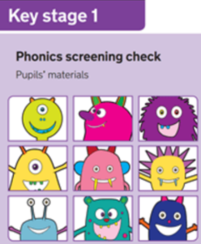
29th April 2022
Dear Parent/Carer,
Phonics Screening Check for Year One pupils

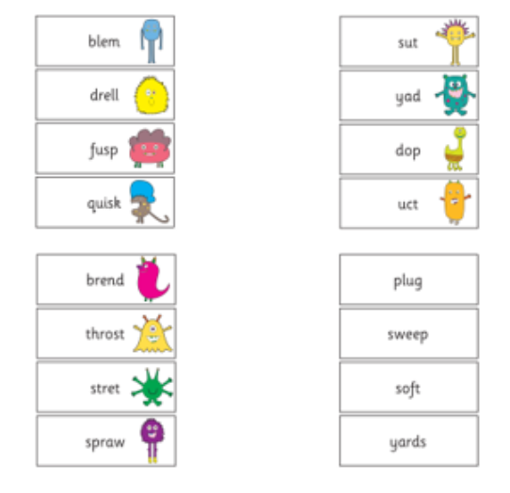
As you may be aware your child will take part in a short Phonics Screening Check in June. It checks that a child can sound out and blend graphemes in order to read simple words, read decodable one and two-syllable words. They will also read a selection of nonsense (pseudo) words. This is to ensure that your child can decode words using phonic skills and not their memory.
The main purpose of this phonics check is to see which children might benefit from additional support with their phonics, so that every child gets the opportunity to master this vital reading skill. We will ensure that this is not a stressful situation and Miss Cox is well equipped to listen to and understand your child’s level of skills.

Please take a look at the Early Phonics and Reading page on our school website for a short video and to see examples of past papers.
www.roundswellprimary.devon.sch.uk/early-reading-and-phonics
You will be informed of your child’s results in the annual school report which you will receive at the end of the Summer Term. If your child does not reach the expected standard in this Phonics Check we will continue to give your child specific support within lessons. They will then complete the Phonics Screening Check again in Year Two.

Please do not hesitate to contact myself or Miss Cox if you require further information,
Kind regards,

Jo Burtoft
English Lead

